
DEPARTMENT OF

COMPUTER SCIENCE & ENGINEERING

Experiment 1
Student Name: Raj Gupta UID: 23BAI70387
Branch: AIT_CSE Section/Group: 23AIT_KRG_G2
Semester: 6th Date of Performance:14-01-26
Subject Name: Full Stack II Subject Code: 23CSH-382

- Aim:

To design and develop a web-based Environmental Impact Tracker (EcoTrack) that calculates and categorizes carbon footprint based on different daily activities using ReactJS.

- Objective:

The main objectives of this experiment are:
- To understand the use of React components for UI development
- To calculate total carbon footprint using JavaScript logic
- To classify activities into High Carbon and Low Carbon emissions
- To design a minimalist and user-friendly dashboard UI
- To improve understanding of arrays, filter, reduce, and conditional rendering

- Implementation/Code:

=>App.jsx

import React from "react";
import Header from "./components/Header";
import Dashboard from "./pages/Dashboard";
import Logs from "./pages/Logs";

const App = () => {
return (
<div>
<Header title="EcoTrack – Environmental Impact Tracker" />
<main className="app-container">
<Dashboard />
<Logs />
</main>
</div>
);
};

export default App;
=>logs.js

const logs = [
{ id: 1, activity: "Car Travel", carbon: 4 },
{ id: 2, activity: "Electricity Usage", carbon: 6 },
{ id: 3, activity: "Cycling", carbon: 0 },
{ id: 4, activity: "Bus Travel", carbon: 3 },
{ id: 5, activity: "Solar Energy Usage", carbon: 1 },
{ id: 6, activity: "Flight Travel", carbon: 8 },
];

export default logs;

=>dashboard.jsx

import logs from "../data/logs";

const DashBoard=()=>{
return (
<div>
<div>
<h2>Total Carbon Emissions:{logs.reduce((sum, value) => sum + value.carbon, 0)} kg CO2</h2>
</div>
<div>
<ul>
{logs.map(log => (
<li key = {log.id}>
{log.activity}: {log.carbon} kg CO2
</li>
))}
</ul>
</div>
</div>
)
};
export default DashBoard;

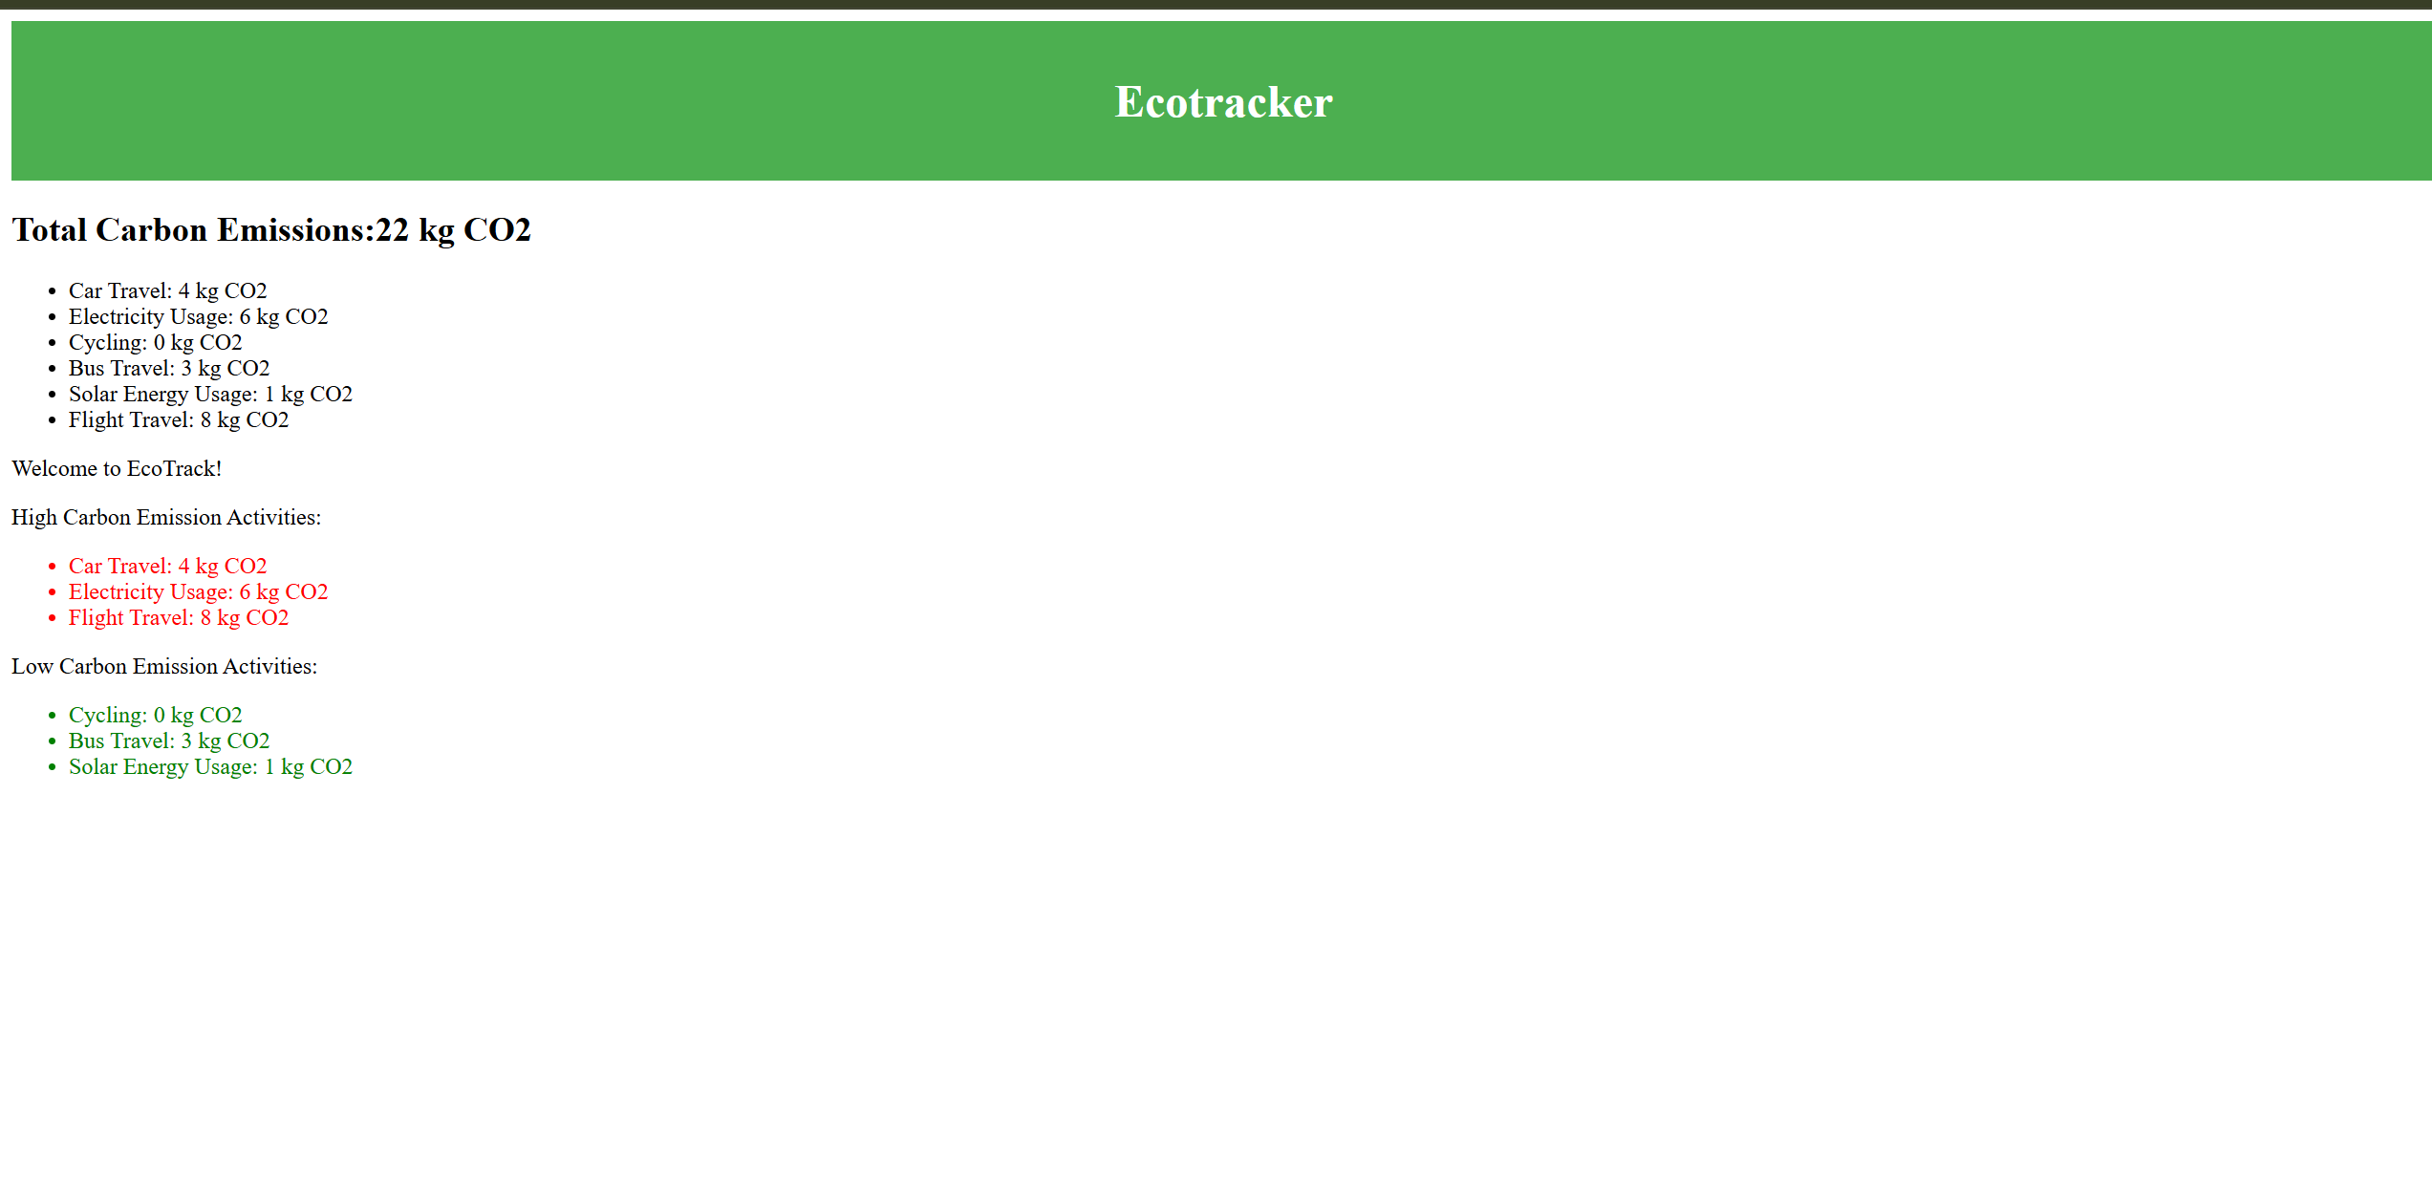
4.Output

5.Learning Outcome
• How to build reusable UI using React components
• Practical use of map(), filter(), and reduce()
• How to manage and display data dynamically in React
• Basics of dashboard UI design with CSS
• Understanding of environmental impact awareness through technology

